# Language detection

We will build a Power Automate flow that checks for the language of an email and then routes it to a specific email inbox.

## Create a flow that detects language and routes to a specific inbox

To create a flow that detects language of an email and then routes it to a specific email inbox, follow these steps:

1. Sign in to Power Automate.
2. Select **Create** from the left navigation bar and then select **Automated flow**.
3. Pick a name for your flow and then select **When a new email arrives** as your flow's trigger.

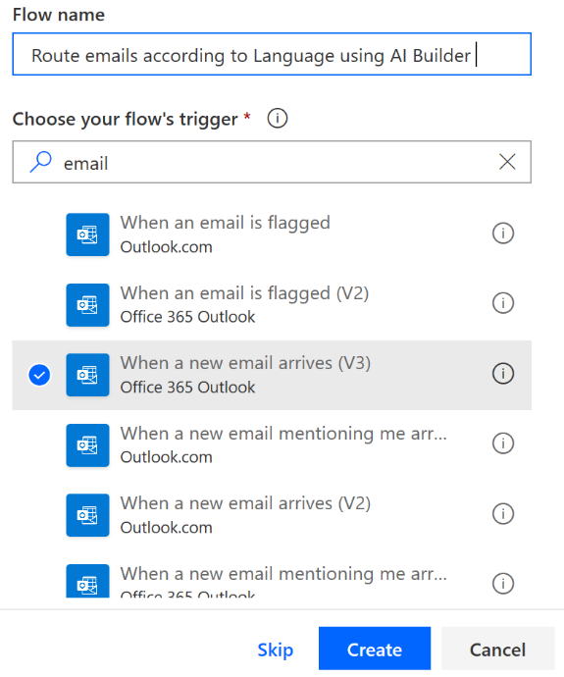

1. Select **Create** and then **New Step**.
2. Search for the **Predict** action and then select it.

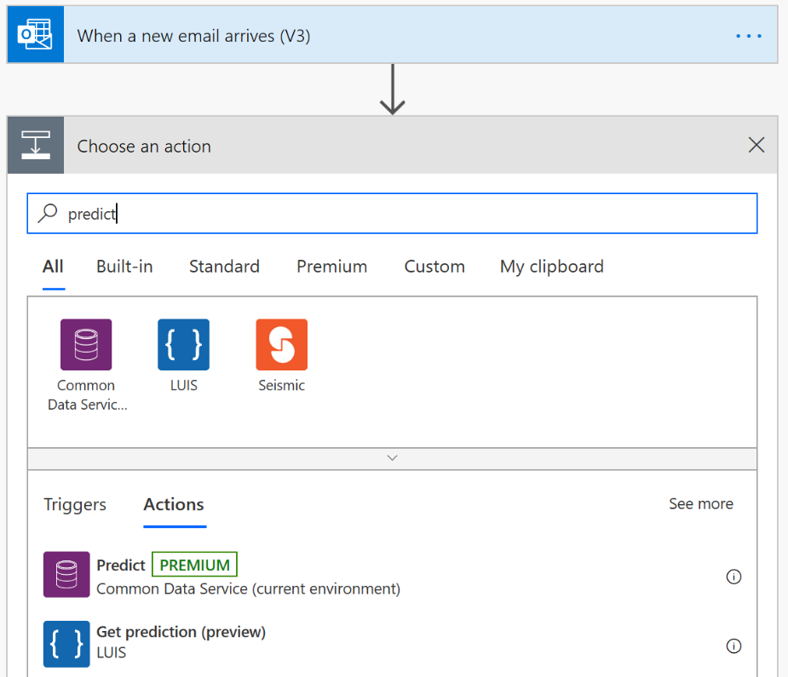

1. Select **LanguageDetection model** from the **Model** drop-down menu, and then select **Body** (or **Body** and **Subject**) from the dynamic content from previous steps.

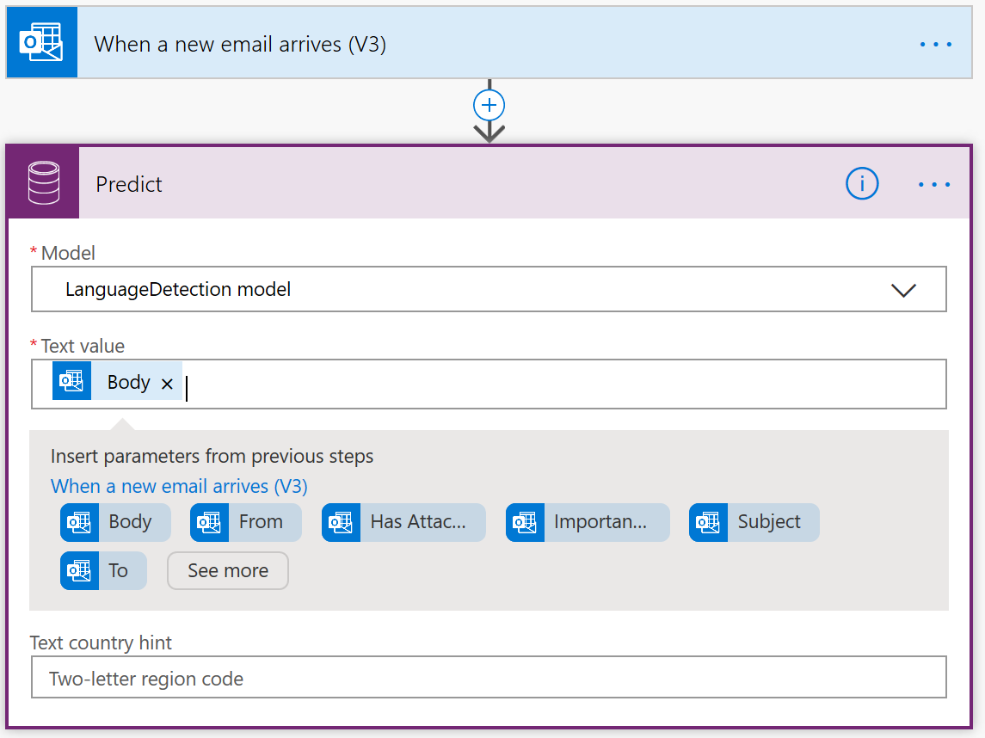

1. Select **New Step** and search for **Condition Control**.

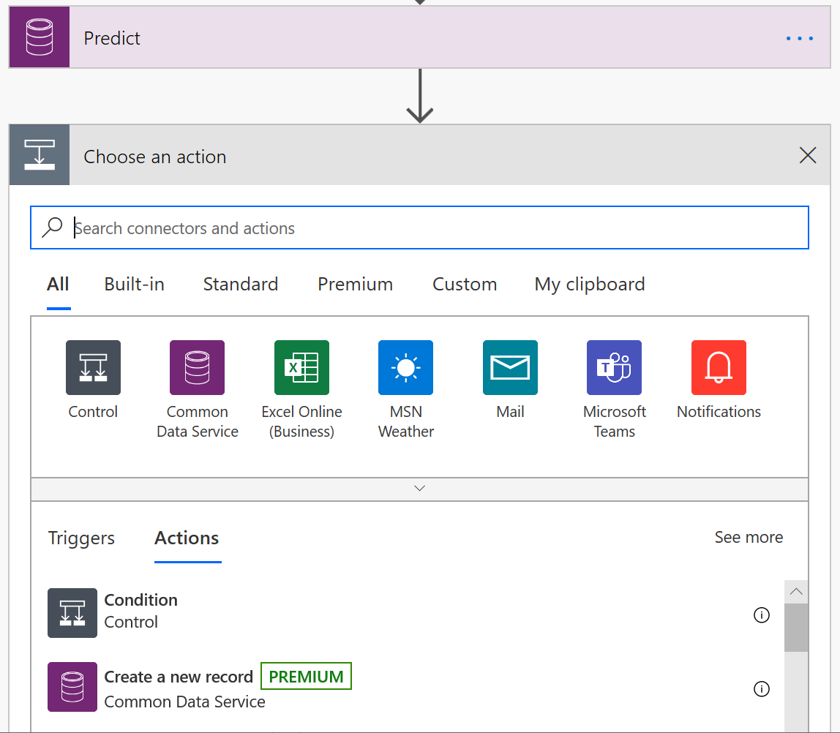

1. Select **Response Results Language** in the **Select output from previous steps** field.

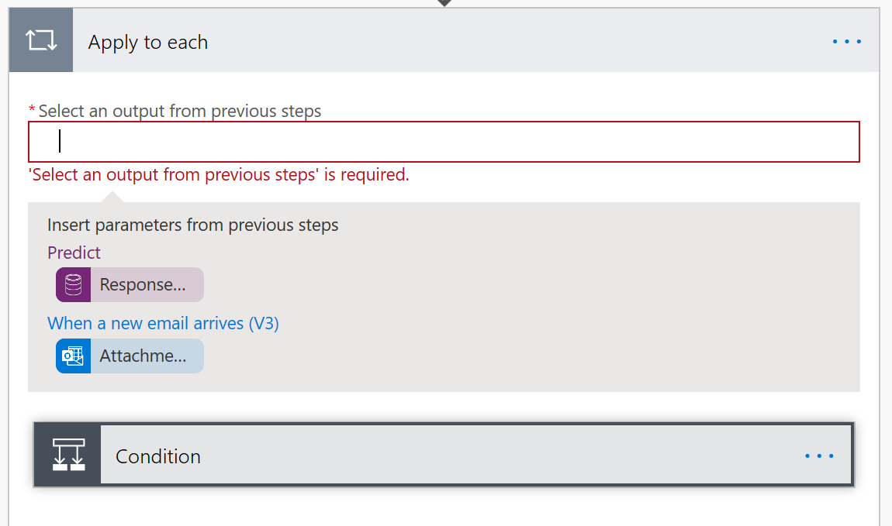

1. Select **Condition** and then enter **FR** (for French), **EN** (for English), **DE** (for German), and so on, to select what language you want to route to a particular email.

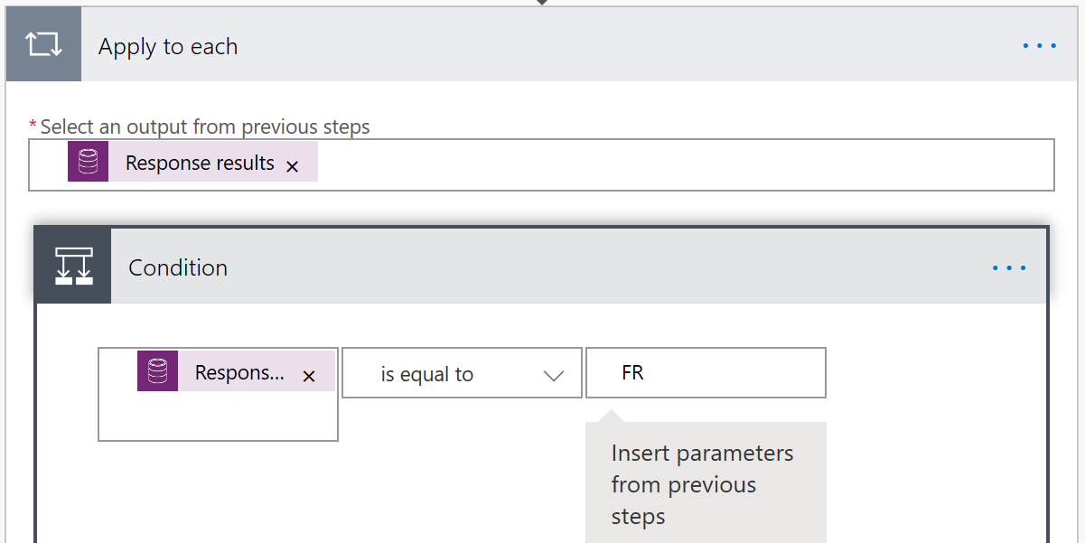

1. Scroll down the page and, under the **If yes** condition, add the **Send an email** action. Select a trigger according to your preferred email provider.

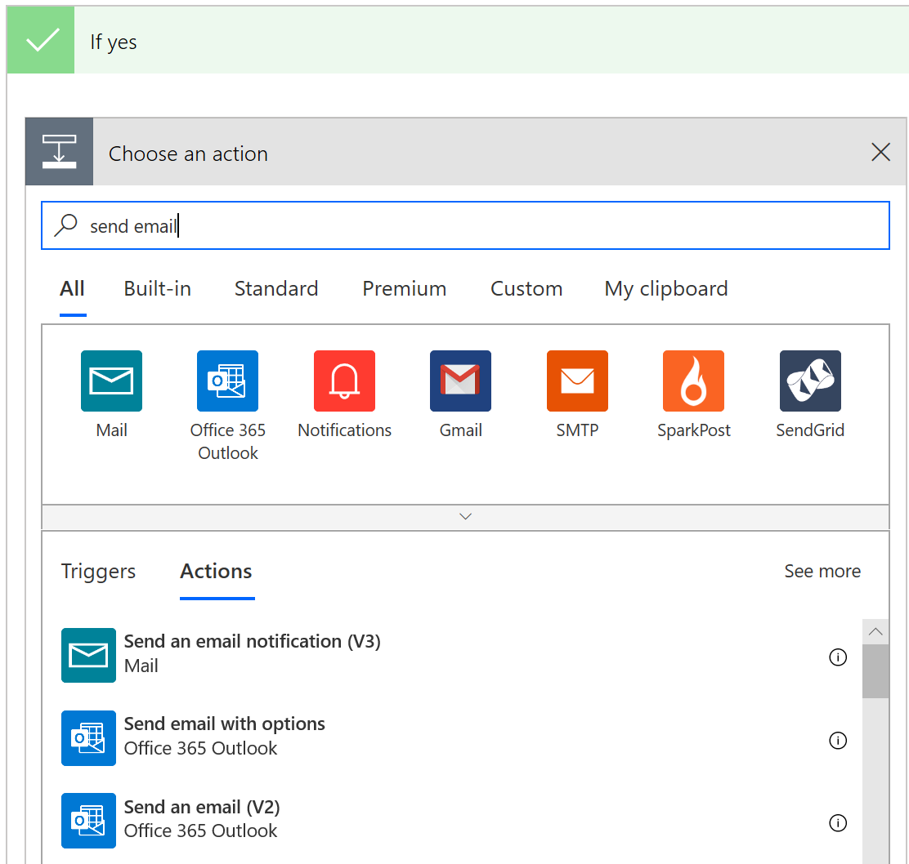

1. Customize the **To**, **Subject**, and **Body** fields by using dynamic content, such as the content shown in the following image.

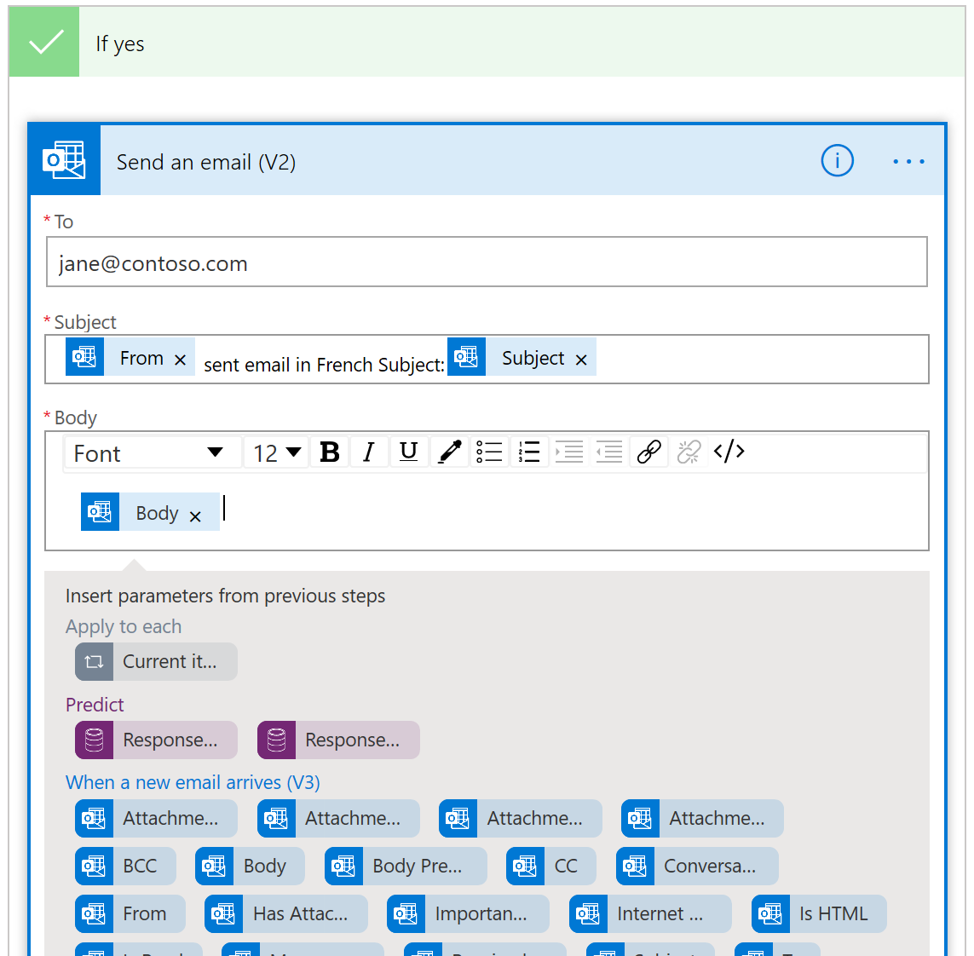

1. Select **Save** and test the flow with a sample email.